 | SIMATS ENGINEERING  Department of Computer Science and Engineering
CSA15 Cloud Computing and Big Data Analytics
CO4 AT2 - Big Data Industry Problem Solving Guided Tool Workbook
Course Code | CSA15 | Slot | B
Assessment | CO4 AT2 | Bloom Level | BL4 - Analyze
Faculty | Dr C. Rajesh Babu | Employee ID | SSETSCS415
Mode | Individual guided tool-based workbook | Submission | GitHub repository link through Google Classroom
End Evidence | Workbook + screenshots + diagrams + dashboard/mockup | Marks | 30

Student Details
Student Name | Konatham Mahesh | Register Number | 192311014
Class / Section |  | Slot | B
Selected Scenario | Weather, soil sensors, crop advisories, pest reports, market prices and farmer app interactions. | Submission Date
GitHub Link |  | Google Classroom Status | https://classroom.google.com/u/1/c/ODcwMzQ3MDExMjg1/a/ODc0NzgwMjM1NTEy/details

Workbook Purpose
What this workbook does
This workbook guides students to use real software tools and official technical references to derive a big-data industry solution. Students should learn from the tool, observe patterns, record evidence and then write their own technical explanation.
- Do not copy full text from websites or AI tools.
- Use official references to justify architecture, processing and security decisions.
- Screenshots are evidence; explanations are the actual assessment answer.

Scenario Bank
Instruction
Faculty may assign one scenario or ask students to complete more than one. If no specific scenario is assigned, select one scenario and complete all tool-guided sections for that scenario.
No. | Scenario | Data Context
1 | Healthcare Emergency Analytics | Emergency department data, ambulance updates, bed availability, alerts and treatment delays.
2 | E-Commerce Customer Behavior Intelligence | Clickstream events, cart abandonment, payment failure, campaign traffic and recommendation impact.
3 | Smart Agriculture Advisory Platform | Weather, soil sensors, crop advisories, pest reports, market prices and farmer app interactions.
4 | Cybersecurity Threat Monitoring | Authentication logs, firewall alerts, API access logs, failed login attempts and suspicious network events.
5 | Public Transport Demand Analytics | Ticketing data, bus GPS, passenger count, route delay, peak-hour demand and crowding alerts.

Selected Scenario and Reason
Type response / paste screenshot / paste diagram here.
This scenario involves weather information, soil sensor data, crop advisories, pest reports, market prices, and farmer app interactions. Big-data analytics can combine these different data sources to identify patterns and provide timely recommendations for irrigation, crop health, pest management, and market conditions. It is suitable for studying data ingestion, storage, batch and streaming processing, analytics, security, and dashboard-based decision making.

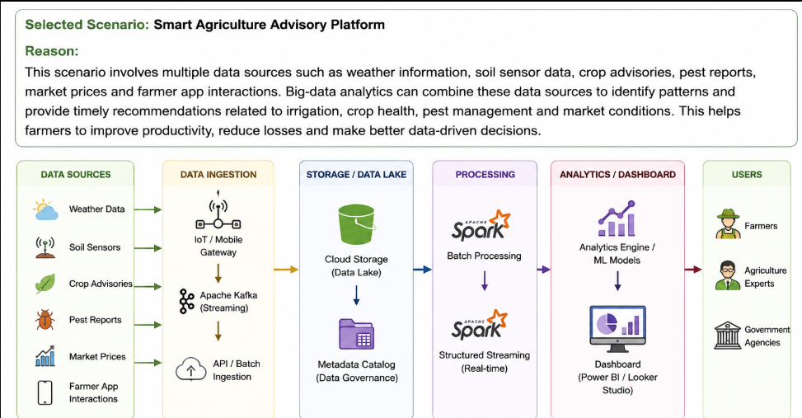

Guided Tool Module 1: Use Cloud Architecture Centers
Purpose: Use official cloud architecture references to identify suitable ingestion, storage, processing, analytics and security components for the selected scenario.
No. | Perform |  | Observe / Decide |  | Record in Workbook
1 | Open AWS Architecture Center, Azure Architecture Center and Google Cloud Architecture Center in three browser tabs. |  | You are not copying a full architecture. You are learning common cloud patterns and service categories. |  | Paste the three page titles or URLs.
2 | Search each site using terms from your scenario, such as healthcare analytics, streaming analytics, data lake, retail analytics, IoT analytics or security monitoring. |  | Notice which patterns repeatedly appear: ingestion, data lake, warehouse, processing, ML/analytics, visualization and security. |  | Record at least one useful reference from each cloud provider.
3 | Identify the services/components mentioned in the reference diagrams. |  | Separate service category from vendor-specific service name. Example: object storage is the category; Amazon S3/Azure Blob Storage/Cloud Storage are service examples. |  | Complete the tool-category table.
4 | Compare the three references. |  | Choose the most suitable architecture pattern for your scenario and explain why. |  | Write a short justification.
5 | Draw your own provider-neutral architecture in draw.io. |  | Your diagram must show data sources -> ingestion -> storage -> processing -> analytics/dashboard -> users, with security controls. |  | Paste the diagram screenshot/link.
Cloud Provider |  | Reference Page / URL |  | Useful Pattern Found |  | Useful Service Categories
AWS |  | AWS Architecture Center |  | Data lake and analytics architecture: ingestion → storage → processing → analytics |  | Data ingestion, object storage, data processing, analytics/ML, security and governance
Microsoft Azure |  | Azure Architecture Center |  | Data lake/lakehouse architecture with batch and streaming analytics |  | Data ingestion, data lake storage, processing, analytics/ML, visualization, security
Google Cloud |  | Google Cloud Architecture Center |  | Data analytics and streaming architecture |  | Data ingestion, cloud storage, data processing, analytics/ML, visualization, security

Cloud Architecture Justification
The Smart Agriculture Advisory Platform requires an architecture that can handle both continuous and historical agricultural data. Weather updates, soil sensor readings and farmer app interactions may arrive continuously, while market prices, crop records and pest reports can be processed as batch data. A data-lake-based architecture with ingestion, scalable storage, batch and streaming processing, analytics, machine learning and visualization is suitable for this scenario. Security controls such as authentication, authorization, encryption, monitoring and audit logging should be applied across the architecture. This approach supports timely agricultural recommendations while also allowing historical analysis and prediction.

Architecture Diagram Evidence
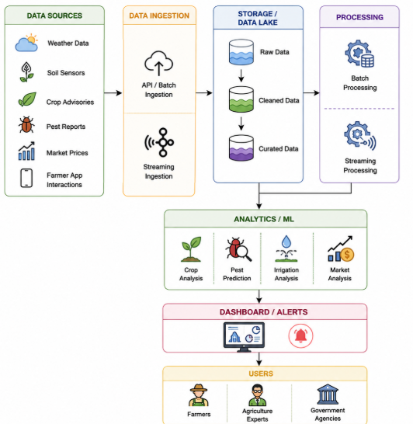

Guided Tool Module 2: Use Hadoop and Spark Documentation
Purpose: Decide whether your problem needs batch processing, streaming processing or hybrid processing by reading official Hadoop/Spark documentation.
No. | Perform |  | Observe / Decide |  | Record in Workbook
1 | Open the Apache Hadoop MapReduce tutorial. |  | MapReduce is suitable when large stored data can be processed in batches, such as daily logs or historical transactions. |  | Write one sentence on what mapper and reducer mean.
2 | Open the Apache Spark Structured Streaming guide. |  | Structured Streaming is suitable when new events continuously arrive, such as sensors, clickstream, live alerts or location updates. |  | Write one sentence on what streaming source, processing and sink mean.
3 | Classify your scenario data into batch data and streaming data. |  | Historical records normally become batch data; live sensor/log/API updates normally become streaming data. |  | Complete the batch-vs-stream table.
4 | Choose one processing approach for your scenario: Hadoop/MapReduce, Spark batch, Spark streaming or hybrid. |  | The decision must match the data velocity and decision urgency. |  | Write your processing decision.
5 | Prepare a simple pseudo-flow, not full code. |  | Example: Mapper reads log line -> emits hour, count. Reducer sums counts. Dashboard shows peak hour. |  | Write pseudo-flow or paste diagram.
Data Item |  | Batch / Streaming |  | Why |  | Suggested Framework
Historical crop records |  | Batch |  | Large stored historical data can be analyzed periodically |  | Spark Batch
Historical pest reports |  | Batch |  | Reports are stored and analyzed for trends |  | Spark Batch
Historical market prices |  | Batch |  | Used for historical price analysis and forecasting |  | Spark Batch
Crop advisory records |  | Batch |  | Existing records can be processed periodically |  | Spark Batch
Soil sensor readings |  | Streaming |  | New sensor readings arrive continuously |  | Spark Structured Streaming
Weather updates |  | Streaming |  | Weather information changes continuously |  | Spark Structured Streaming

Processing Framework Decision
The selected processing approach is Hybrid Processing using Apache Spark Batch and Spark Structured Streaming. Historical crop records, pest reports, market prices and crop advisory records are processed using Spark Batch for trend analysis and forecasting. Soil sensor readings, weather updates, farmer app interactions and live pest alerts are processed using Spark Structured Streaming because these data arrive continuously and require timely decisions. Therefore, the hybrid approach is suitable for the Smart Agriculture Advisory Platform because it supports both historical analysis and real-time agricultural recommendations.

MapReduce / Spark Pseudo-Flow
Type response / paste screenshot / paste diagram here.
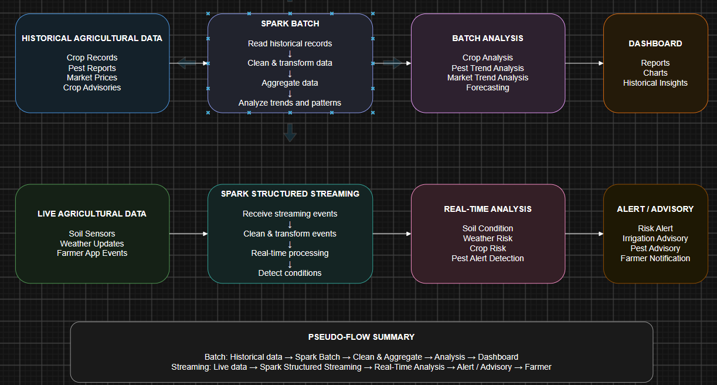

Guided Tool Module 3: Threat Modeling with OWASP Threat Dragon / Microsoft Tool
Purpose: Identify privacy and security risks in the big-data solution before proposing controls.
Tool Choice
Use OWASP Threat Dragon if you need a web/desktop cross-platform threat modeling tool. Use Microsoft Threat Modeling Tool when a Windows system is available. The required evidence is the threat model diagram and threat-control table.
No. | Perform |  | Observe / Decide |  | Record in Workbook
1 | Open OWASP Threat Dragon or Microsoft Threat Modeling Tool. |  | A threat model is a security diagram that shows components, data flows, trust boundaries and possible threats. |  | Write which tool you used.
2 | Create a new threat model named with your scenario. |  | Use a clear title such as CO4_AT2_Healthcare_Emergency_Analytics. |  | Paste model name.
3 | Add external entities. |  | External entities are users/systems outside your platform: patient, customer, sensor, payment gateway, bus GPS device, public API. |  | List at least two external entities.
4 | Add processes and data stores. |  | Processes transform data; data stores hold data. Example: ingestion API, stream processor, data lake, warehouse, dashboard. |  | List processes and stores.
5 | Draw data flows and trust boundaries. |  | Trust boundaries mark where security assumptions change: public internet to cloud, app to API, processing layer to storage. |  | Paste screenshot of DFD.
6 | Identify threats using STRIDE thinking. |  | Spoofing, Tampering, Repudiation, Information Disclosure, Denial of Service and Elevation of Privilege help structure risks. |  | Complete the threat table.
7 | Write mitigations. |  | Controls may include authentication, authorization, encryption, masking, audit logs, rate limits, backup and monitoring. |  | Map every threat to one control.
Component / Data Flow |  | Threat |  | Impact |  | Mitigation
Data Sources – Soil Sensors, Weather, Farmer App |  | Spoofing, fake data, device tampering |  | Incorrect agricultural analysis and recommendations |  | Device authentication, certificates, secure communication, input validation
Data Ingestion – APIs / Gateways |  | Unauthorized access, API abuse, malicious input |  | False data injection and service disruption |  | API authentication, rate limiting, input validation, TLS encryption
Data in Transit |  | Eavesdropping, Man-in-the-Middle attack, data tampering |  | Data leakage or modification |  | HTTPS/TLS encryption, secure protocols, network segmentation
Storage / Data Lake |  | Unauthorized access, data leakage, data deletion |  | Loss of confidentiality, integrity and availability |  | IAM/RBAC, encryption at rest, access logs, backup, versioning
Batch Processing |  | Job manipulation, malicious code, resource exhaustion |  | Incorrect results, processing failure, denial of service |  | Least-privilege access, code review, resource limits, monitoring
Streaming Processing |  | Malicious events, unauthorized access, resource exhaustion |  | Incorrect real-time alerts and service disruption |  | Authentication, input validation, access control, monitoring

Threat Model Diagram Evidence
Type response / paste screenshot / paste diagram here.
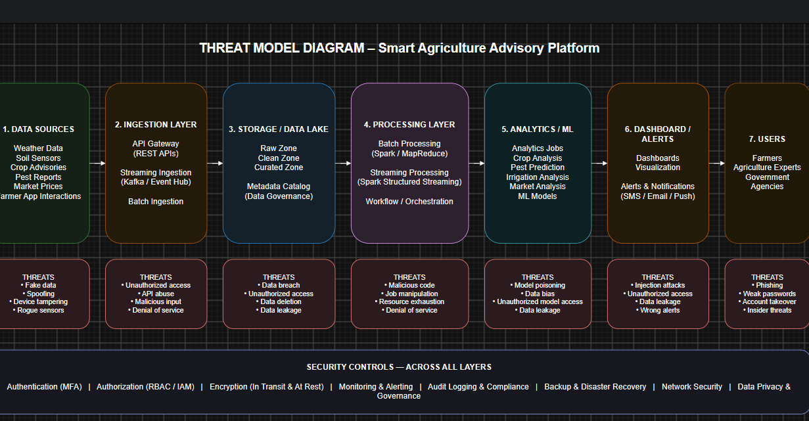

Guided Tool Module 4: Dashboard or Analytics Output Mockup
Purpose: Show how raw big data becomes useful decisions through a dashboard, alert, forecast, recommendation or report.
Beginner-Friendly Choice
Use any one: Power BI, Looker Studio, Tableau Public or Canva. If login/install is difficult, Canva dashboard mockup is acceptable. If data connection is possible, Power BI/Looker Studio/Tableau Public is stronger.
No. | Perform |  | Observe / Decide |  |  | Record in Workbook
1 | Prepare a small sample dataset in Excel or Google Sheets with 10-20 rows. |  | Columns should match your scenario. Example: timestamp, user/location, event type, value, status, risk level. |  |  | Paste column names.
2 | Choose the dashboard tool. |  | Power BI/Tableau/Looker are analytics tools; Canva is acceptable for visual mockup when live data connection is blocked. |  |  | Write chosen tool and reason.
3 | Import or recreate the sample data. |  | In Power BI/Looker/Tableau, connect data. In Canva, manually create charts from sample values. |  |  | Paste screenshot of data/chart setup.
4 | Create at least three visual elements. |  | Use KPI card, bar chart, line chart, table, map, alert count or pie/donut chart as appropriate. |  |  | List the visuals.
5 | Add decision labels. |  | A dashboard is useful only if it supports a decision: allocate beds, detect fraud, reroute buses, restock products, warn farmers. |  |  | Write decision supported by each visual.
6 | Export/share screenshot. |  | Paste the final dashboard screenshot or public/report link if available. |  |  | Paste evidence.
Dataset Column |  | Meaning |  |  | Example Value
Timestamp |  | Date and time of observation |  |  | 2026-08-26 08:30
Location |  | Farm location |  |  | Chennai
Crop |  | Crop being monitored |  |  | Rice
Soil Moisture |  | Soil moisture percentage |  |  | 42%
Temperature |  | Current temperature |  |  | 31°C
Humidity |  | Relative humidity |  |  | 68%
Visual Element |  | Metric Shown |  | Decision Supported
KPI Card – Average Soil Moisture |  | 42% |  | Decide whether irrigation is required
Bar Chart – Crop Health by Crop |  | Good / Medium / Poor crop health |  | Identify crops requiring attention
Line Chart – Temperature & Soil Moisture |  | Changes over time |  | Identify irrigation or weather-related risks
Pest Risk Indicator |  | Low / Medium / High |  | Decide whether pest control action is required

Dashboard / Analytics Output Evidence
Type response / paste screenshot / paste diagram here.

Final CO4 AT2 Solution Sections
Final Assembly
After completing the guided tool modules, combine the evidence into the final solution. The final answer must show technical reasoning, not only screenshots.

1. Problem Understanding
What to include: Identify stakeholders, decisions required, data produced, expected analytics output and urgency.

Student Response
Type response / paste screenshot / paste diagram here.
The Smart Agriculture Advisory Platform supports farmers, agricultural experts and administrators in making faster and better farming decisions. The main stakeholders are farmers, agricultural experts, market analysts and system administrators. The platform collects soil moisture, temperature, humidity, rainfall, crop health, pest reports, market prices and farmer application data. The required decisions include when to irrigate crops, when to take pest-control action, how to identify crop-health problems and when to sell crops based on market conditions. The expected analytics output includes dashboards, risk indicators, alerts and farming recommendations. Real-time soil and weather information requires urgent processing so that farmers can take action before crop conditions become critical.

2. 5Vs Mapping
What to include: Map Volume, Velocity, Variety, Veracity and Value using scenario evidence.

Student Response
Type response / paste screenshot / paste diagram here.
Volume: The platform can generate large amounts of sensor readings, weather records, crop history, pest reports, market prices and farmer activity data over long periods.
Velocity: Soil sensors, weather services and farmer applications can continuously generate new data, requiring real-time or near-real-time processing.
Variety: The system handles structured data such as market prices, semi-structured sensor records and application logs, and unstructured information such as pest reports and advisory content.
Veracity: Agricultural data may contain missing values, inaccurate sensor readings, duplicate records or incorrect reports. Data validation, cleaning and quality checks are therefore required.
Value: The processed data provides useful decisions such as irrigation recommendations, pest-risk alerts, crop-health monitoring and market-based selling guidance.

3. Big Data Architecture
What to include: Paste final draw.io architecture showing sources, ingestion, storage, processing, analytics/security and users.

Student Response
Type response / paste screenshot / paste diagram here.
The proposed architecture consists of multiple data sources, an ingestion layer, scalable data-lake storage, batch and streaming processing, analytics and machine-learning services, dashboards and alerts, and farmers or agricultural experts as end users. Soil sensors, weather data, crop records, pest reports, market prices and farmer applications provide the input data. The ingestion layer receives both continuous and periodic data. The data lake stores historical and raw data. Batch processing is used for historical analysis, while streaming processing is used for real-time soil and weather information. Analytics and machine learning generate crop-risk and advisory outputs. Security and governance controls are applied across all layers.

4. Data Flow Pipeline
What to include: Explain how raw data moves, gets cleaned, stored, processed and converted into dashboard/alert/decision.

Student Response
Type response / paste screenshot / paste diagram here.
Raw data is collected from soil sensors, weather sources, crop records, pest reports, market systems and farmer applications. The ingestion layer receives the incoming data and performs validation and preprocessing. Data is cleaned by removing duplicates, handling missing values and checking invalid readings. Cleaned data is stored in the data lake for historical analysis. Batch processing analyzes historical crop, pest and market information, while streaming processing analyzes live soil and weather data. Analytics and machine-learning models identify crop conditions, pest risks and irrigation requirements. The results are presented through dashboards, alerts and farmer advisories, allowing users to make timely agricultural decisions.

5. Tool and Technology Justification
What to include: Use cloud architecture references and Hadoop/Spark documentation to justify chosen tools.

Student Response
Type response / paste screenshot / paste diagram here.
A cloud-based data-lake architecture is suitable because the platform must handle scalable agricultural data from multiple sources. Cloud object storage can provide durable and scalable storage for raw and processed datasets. Apache Spark is suitable for both batch analytics and real-time stream processing. Spark Batch can analyze historical crop, pest and market data, while Spark Structured Streaming can process continuously arriving soil and weather information. Dashboard and analytics tools can present KPIs, crop-health trends, soil-moisture trends, pest-risk indicators and market information. Cloud identity, encryption, monitoring and access-control services can provide security and governance. This combination supports scalability, flexible analytics and near-real-time decision making.

6. Security and Privacy Strategy
What to include: Use threat model output to explain threats and controls.

Student Response
Type response / paste screenshot / paste diagram here.
The major threats include unauthorized access to farmer information, interception of data during transmission, compromised data sources, incorrect or manipulated sensor readings, insecure APIs and excessive user privileges. Authentication and role-based authorization should restrict access according to user responsibilities. Encryption should protect data during transmission and storage. Input validation and data-quality checks should identify abnormal or manipulated values. API security and rate limiting should protect application interfaces. Logging and monitoring should record important activities and support incident detection. Sensitive farmer information should be collected only when required and should be protected through appropriate access controls and privacy practices.

7. Challenges and Solutions
What to include: Write at least four big-data implementation challenges and one practical solution for each.

Student Response
Type response / paste screenshot / paste diagram here.
Challenge 1 – Large Data Volume: Continuous agricultural and historical data can become very large.
Solution: Use scalable cloud storage and distributed processing with Spark.
Challenge 2 – Real-Time Processing: Soil and weather data may need immediate analysis.
Solution: Use streaming ingestion and Spark Structured Streaming for near-real-time processing.
Challenge 3 – Poor Data Quality: Sensor failures, missing values and duplicate records can reduce analytical accuracy.
Solution: Apply validation, cleansing, deduplication and data-quality checks before analytics.
Challenge 4 – Security and Privacy: Farmer and operational data may be accessed by unauthorized users.
Solution: Use authentication, role-based access control, encryption, monitoring and audit logging.

8. Business Outcome
What to include: State measurable outcome: faster decision, reduced fraud, lower waiting time, improved prediction, lower downtime or better user experience.

Student Response
Type response / paste screenshot / paste diagram here.
The Smart Agriculture Advisory Platform can improve agricultural decision making by providing timely recommendations based on combined historical and real-time data. The expected outcomes are faster irrigation decisions, earlier identification of pest and crop-health risks, improved use of water and other farm resources, better awareness of market conditions and improved farmer experience. The dashboard and alert system can reduce the time required to interpret raw agricultural data and convert it into actionable recommendations. The solution therefore provides measurable value through faster responses, better resource utilization and more informed farming decisions.

Rubric
Criteria | Marks | Evaluation Focus | Evidence
Problem and 5Vs analysis | 6 | Scenario-specific analysis and correct big-data reasoning | Workbook tables
Architecture and data flow | 6 | Correct pipeline, cloud components and flow clarity | draw.io diagram
Processing framework decision | 5 | Batch/streaming/hybrid justification using Hadoop/Spark concepts | Decision table
Security and privacy | 5 | Threat model, risks and controls | Threat model table/screenshot
Dashboard/output design | 4 | Useful decision-oriented analytics output | Dashboard/mockup
Clarity and submission quality | 4 | Organized, original, complete evidence | GitHub/GCR

Submission Checklist
- Student details and selected scenario are filled.
- Cloud architecture references are recorded.
- Hadoop/Spark processing decision is completed.
- Threat model diagram/table is included.
- Dashboard/mockup screenshot or link is included.
- Final solution sections are completed.
- DOCX/PDF and supporting files are uploaded to GitHub.
- GitHub repository link is submitted through Google Classroom.

Official Reference Links
AWS Architecture Center: https://aws.amazon.com/architecture/
Azure Architecture Center: https://learn.microsoft.com/en-us/azure/architecture/
Google Cloud Architecture Center: https://docs.cloud.google.com/architecture
Apache Hadoop MapReduce Tutorial: https://hadoop.apache.org/docs/stable/hadoop-mapreduce-client/hadoop-mapreduce-client-core/MapReduceTutorial.html
Apache Spark Structured Streaming: https://spark.apache.org/docs/latest/streaming/index.html
Microsoft Threat Modeling Tool releases: https://learn.microsoft.com/en-us/azure/security/develop/threat-modeling-tool-releases
OWASP Threat Dragon: https://owasp.org/www-project-threat-dragon/
Power BI documentation: https://learn.microsoft.com/en-us/power-bi/
Looker Studio create report: https://docs.cloud.google.com/data-studio/create-a-report
Tableau Public: https://www.tableau.com/community/public
Canva Charts: https://www.canva.com/help/charts/

